Task 4: Year 11 General Human Biology
Respiratory and Circulatory Systems Test

Section 1: Multiple choice (15 marks) Answer on the answer sheet provided.

1 | A | B | C | D |  | 11 | A | B | C | D
2 | A | B | C | D |  | 12 | A | B | C | D
3 | A | B | C | D |  | 13 | A | B | C | D
4 | A | B | C | D |  | 14 | A | B | C | D
5 | A | B | C | D |  | 15 | A | B | C | D
6 | A | B | C | D
7 | A | B | C | D
8 | A | B | C | D
9 | A | B | C | D
10 | A | B | C | D

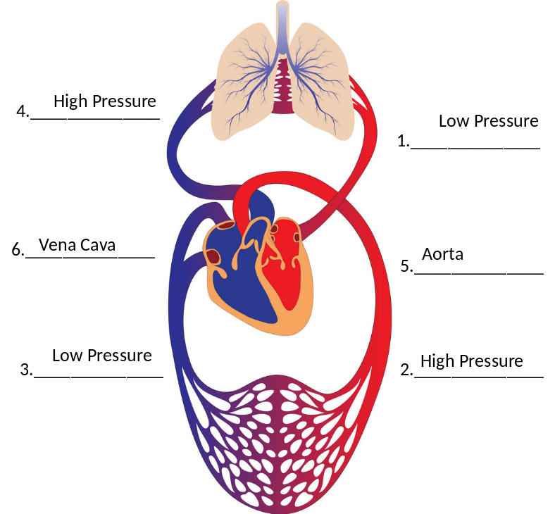
Section 2: Short answer (31 marks)

16. In the diagram to the right label in spaces marked 1-4, the sections of the circulatory system that are under high or low pressure. (4 marks)

In the spaces 5 and 6 correctly name the blood vessel identified. (2 marks)

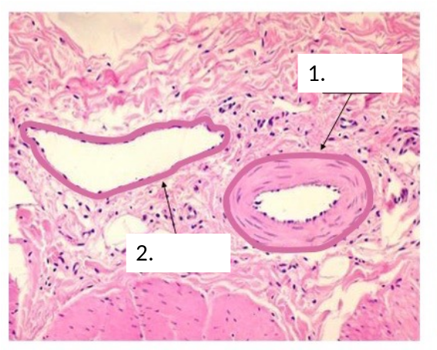
17. In the image identify which is and artery and which is a vein and provide a reason for the differences observed. (3 marks)
- Artery (1 mark), 2. Vein (1 Mark)
Artery walls thicker because they need to be stronger to support the high blood pressure from the heart ( 1 mark)
_____________________________________________________________
_____________________________________________________________

18. Explain the function of plasma in the body, and list two things other than cells found in plasma. (3 marks)

Plasma serves as a transport medium for delivering substance to and from cells in different parts of the body. (1 mark)
Digested food, Wastes, Hormones, Salts, Heat_____________________________________________(2 marks)_______

19. Name 2 conditions/ dysfunctions of the circulatory system. 1 mark per dysfunction Eg: heart attack, blood clots, leukemia, stroke, angina etc.

- (2 mark)

- Describe the process of inhalation.

Rib cage moves upwards (1 mark) and outwards (1mark)
Diaphragm flattens (1 mark)
Chest cavity gets larger (or Pressure decrease) and air moves in (1 mark) MUST HAVE BOTH

21. List the organs of the respiratory system in the order that air passes through them
1 mark each
Nasal cavity/mouth
- pharynx
- larynx
- trachea
- bronchus OR bronchi
- bronchioles
- alveoli
- marks)

22. Label the diagram below image of diffusion
one mark each!
- Red blood cell
- 02
- mark)

23. What passive form of transport is occurring in the above image? Explain how this process facilitates gas exchange in the lungs. (4 marks)

Diffusion (1) CO2 is in high concentration in the capillary coming into the alveoli where it is low (1) CO2 will diffuse from the capillary into the alveoli down the concentration gradient (1) O2 is in high concentration in the alveioli and low in the capillary (1) O2 will diffuse from alveoli into the capillary down the concentration gradient (1)

24. What is the material the supports the air passages in the respiratory tract? (1 mark)

_Cartlidge ____________________________________________________________________________________________________________

25. List the FOUR ways that the rate of gas exchange is increased in the alveoli. (4 marks)

1.________They very thin (single cell) walls ____________________
2.________They have large surface areas______________
3._______They are moist________________________________________________________________
4.________They have a large blood supply______________________

End of Assessment

